**Internet of Everything (IoE)**

**IoT – MOBILITY AND SETTINGS**

**Localization:**

* Traditional location technique such as GPS cannot be used in WSNs directly, as it is costly requirement of sophisticated equipment and high energy consumption, which have greatly constrained the application scale of WSNs.
* In WSNs energy conservation has been considered as the core issue and thus the costs as well as size of node should be as small as possible, to apply into large-scale applications for a long time.
* To address this issue, many localization algorithms developed do not use GPS technique directly, but employ it as an assistance in some cases, and more efforts are made on the excavation of WSNs itself.

**Types of Localization:**

1. **Range-based localization** – It needs an extra hardware to accomplish ranging and then utilizes some algorithm to calculate the coordinates. Range-based algorithms calculate location information from the range-based measurement techniques like Received Signal Strength (RSS), Time of Arrival (ToA), Time Difference of Arrival (TDoA) and Angle of Arrival (AoA).
2. **Range-free localization** – It exploits the characteristics of the network connectivity. Range free algorithms calculate the location information from the connectivity information. Some physical measurement-based localization schemes are classified as Coarse-Grained and Fine-Grained.

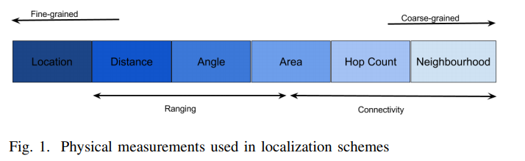

Fig. Physical measurements used in Localization.

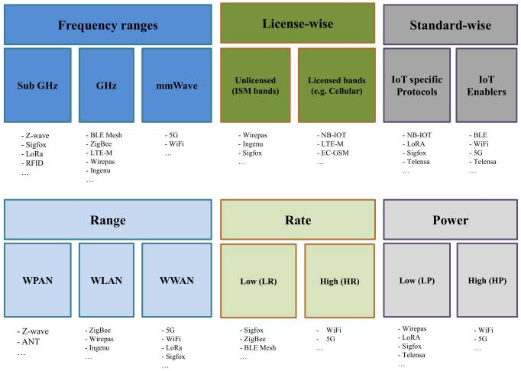

**Mobility Management:**

Mobility management is one of the major functions of a GSM or a UMTS network that allows mobile phones to work. The aim of mobility management is to track where the subscribers are, allowing calls, SMS and other mobile phone services to be delivered to them.

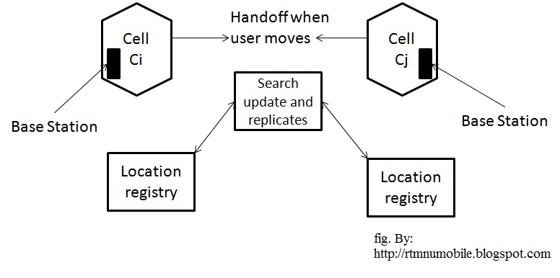

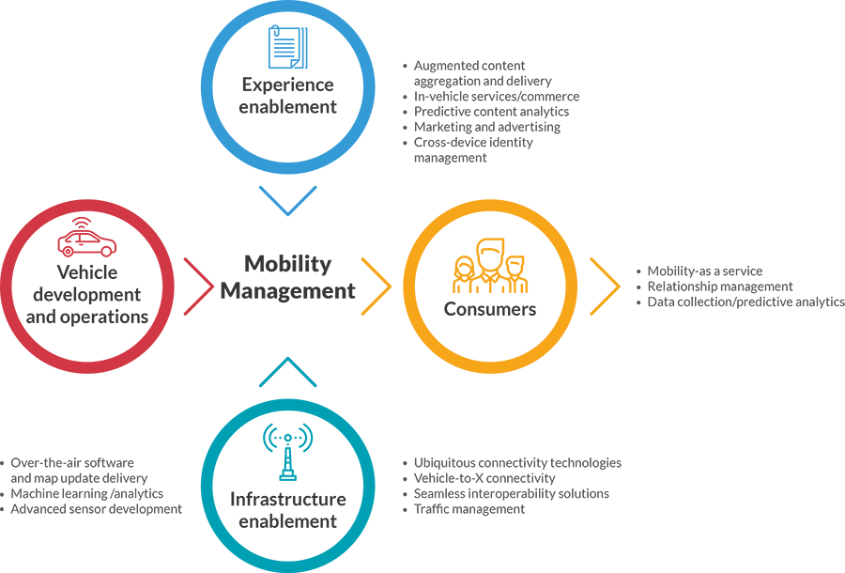

**Enterprise Mobility Management:**

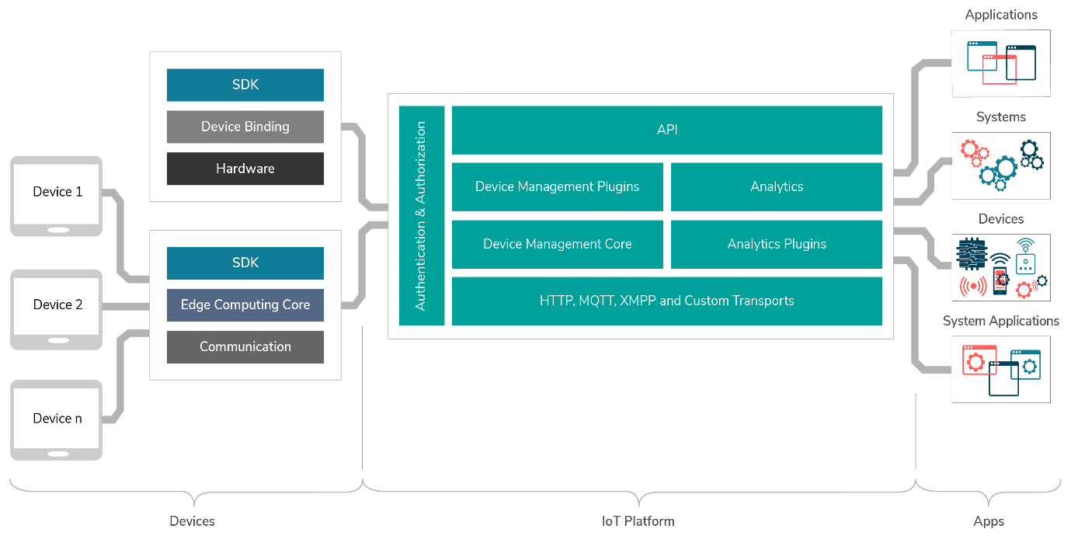

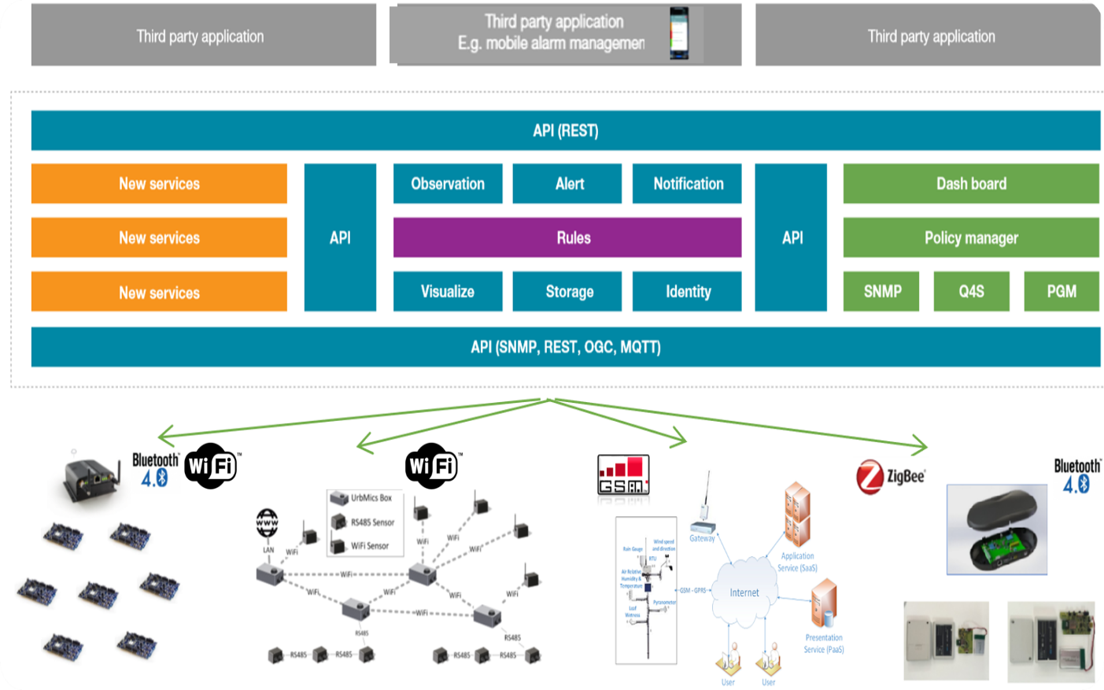

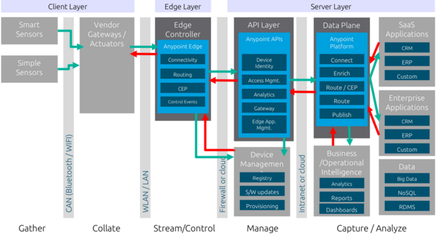

**Handover Management:**

Handover management enables the network to keep active connections during the Mobile Terminal (MT) movement or even balance the network load evenly among different areas. In a network-controlled handover, the network decides based on the measurements of the received radio signal from the MTs at a number of access points.

**IPv4 vs IPv6:**

1. Efficient routing is achieved by using flexible address (hierarchical) and fragmentation at source host and discover the paths of a maximum of transmission unit (MUT).
2. Efficient packet processing is achieved by removing the checksum process and the options from the IP header. The checksum is put in the extension field to make IP header more flexible for mobility.
3. Improved security by using the IPsec protocol achieves better security than IPv4.
4. Auto-configuration helps in getting care of addresses.
5. More addresses space: space to cover the high demands of addresses in the next 20 years. This is due to the vast growth of Internet devices.
6. End-to-end transparency: as a result, to the vast address of IPv6, the nodes can communicate directly (end-to-end). It increases the security and performance.
7. In addition to the aforementioned features, there are some other features such as easy managements, multi-cast process for using bandwidth in an efficient way (directed data flows), and scalability make the IPv6 more suitable for mobility applications.

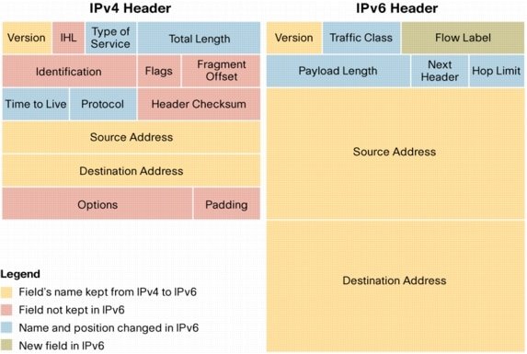

Fig. IPv4 vs IPv6 Header format.

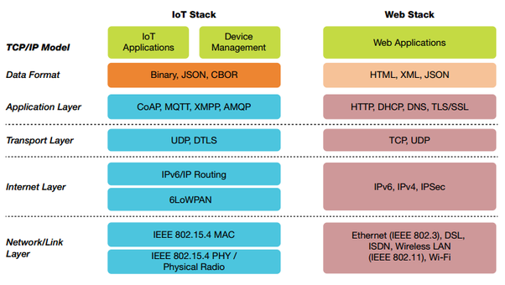

Fig. IoT Stack vs Web Stack.